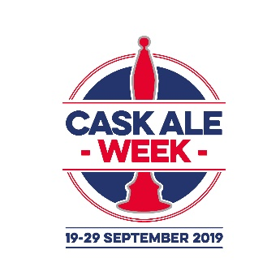 | Team Name:  Round No:

Answers | Notes
Q1.
Q2.
Q3.
Q4.
Q5.
Q6.
Q7.
Q8.
Q9.
Q10.

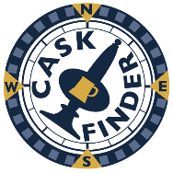 | Get the CaskFinder App free of charge – scan the QR Code below or visit http://cask-marque.co.uk/app  Find Cask Marque pubs, join ale trails, view beer tasting notes and more

All questions correct at time of writing July 2019 – written by Cask Marque; independently checking beer quality across the UK since 1997.

